**Dataset for final evaluation:-**  
<https://huggingface.co/datasets/Amod/mental_health_counseling_conversations>  
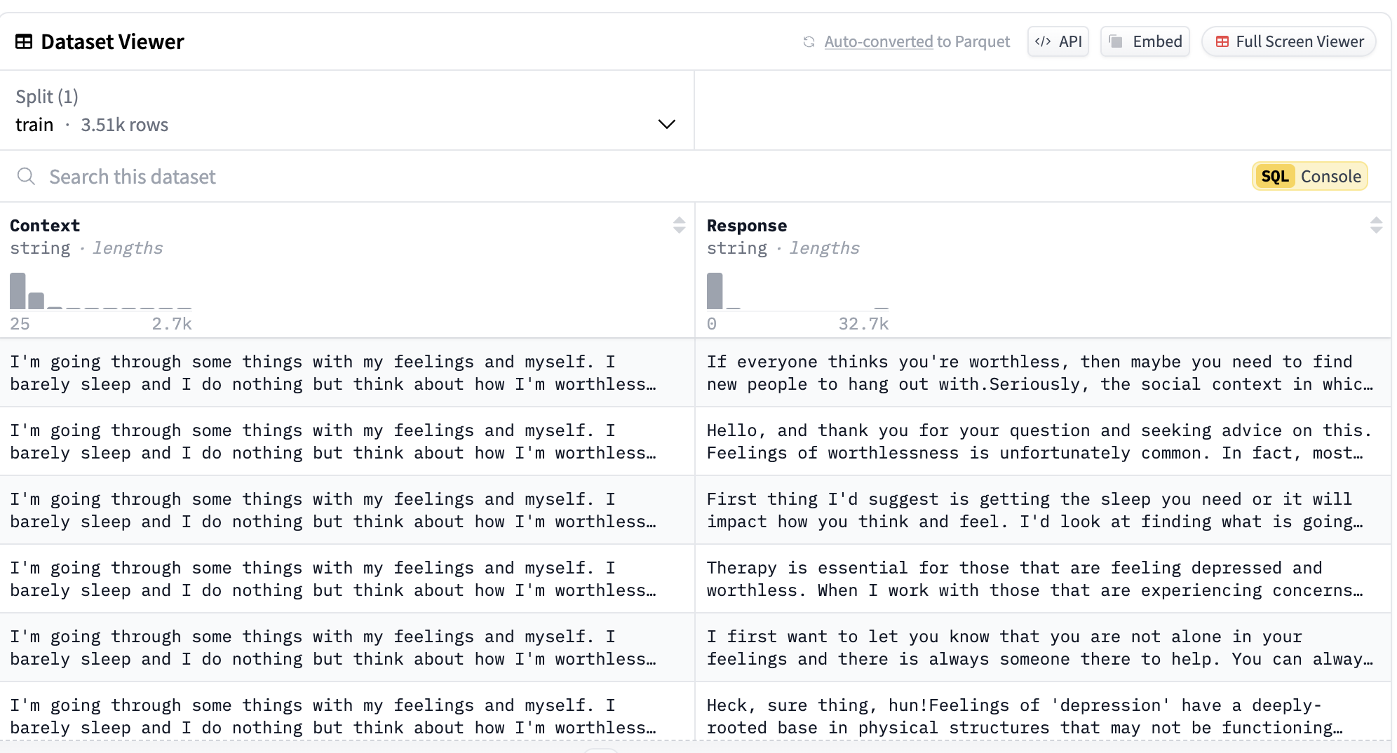  
The mental_health_counseling_conversations dataset, curated by Amod and hosted on Hugging Face, is a collection of text-based interactions between individuals seeking mental health advice and qualified psychologists. The dataset comprises of 3,510 entries.  
**Key Features:**

->The dataset includes questions on various mental health topics, such as anxiety, depression, relationships, and self-esteem, with corresponding professional responses.

-> Each entry consists of two fields:

Context: The user’s question or concern.

Response: The psychologist’s answer or advice.  
  
**Potential Applications:**

**Natural Language Understanding (NLU) and Response Quality Analysis**

• Assessing the complexity and relevance of psychologist responses.

• Analyzing how context aligns with the corresponding response.

• Identifying cases where responses may lack clarity or empathy.